**How to install Unsigned Drivers on Windows 10:**

This is a temporary way to let driver signature enforcement disabled. It will become enabled the next time you reboot Windows 10 unless you try this way again. The following are the instructions:

**Step 1:** Press Win + X, navigate to “Shutdown,” then Shift + left-click on the “Restart” option. This action will restart your system and will take you to the Advanced Boot menu.

**Step 2:** Select the “Troubleshoot” option in the Advanced Boot menu.

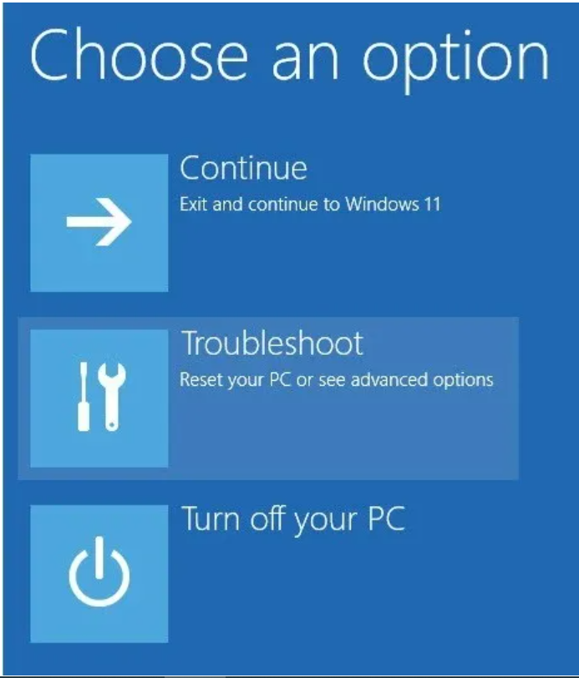

**Step 3:** In the Troubleshooting section, select “Advanced Options.”

**Step 4:** Select “Start-up Settings.” The Startup Settings option will allow you to boot your Windows system in different modes.

**Step 5:** Click on the “Restart” button to continue.

**Step 6:** Since we need to install unsigned drivers, press F7 on your keyboard to select the seventh option: “Disable driver signature enforcement.”  
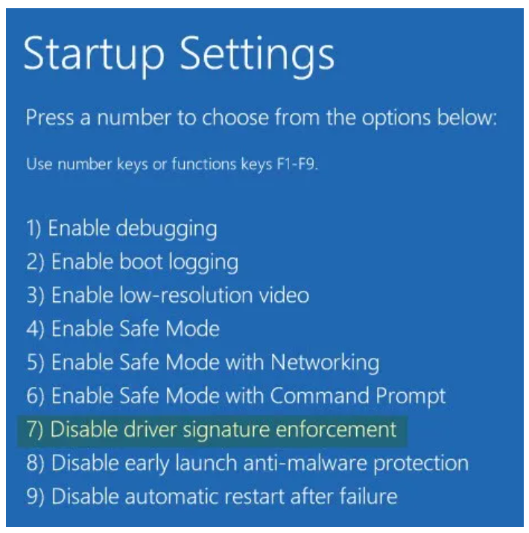

As soon as you select it, your system will boot into Windows. You can then install unsigned drivers in Windows without issues.

(After installing, restart your system, and the Driver Signature Enforcement will be automatically enabled from the next reboot. Therefore, you don’ need to worry!)

**Step 7:** After your system boot into windows, setup USB connection between RA EK board and your PC/NB.

Note: The RA example project on EK-RA6M5 uses the USB FS, so you should get USB cable connected to the J11.

**Step 8:** Open Device Manager and you will find out that there is an unknown USB device under "Other devices" category.

**Step 9**: Right click this unknown USB device and select **Update driver**.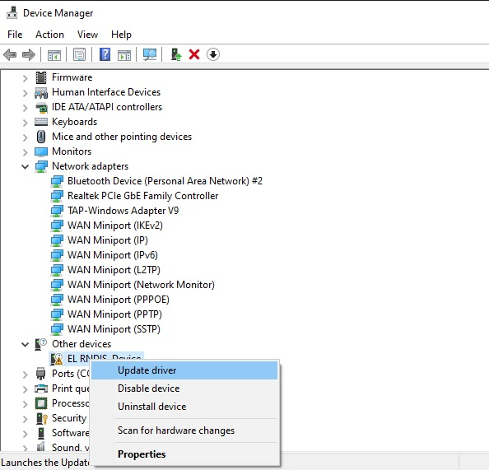

**Step 10**: following below picture, select **Browse my computer for drivers**.

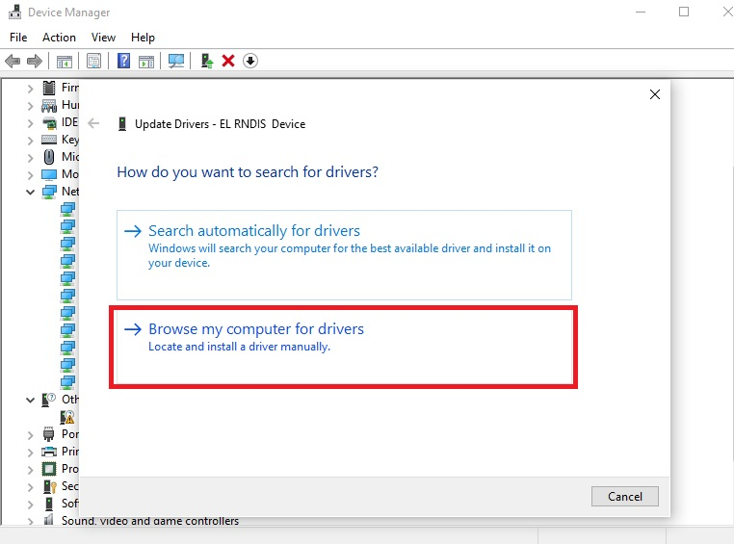

**Step 11**: follow below picture to pick the available driver on my computer.

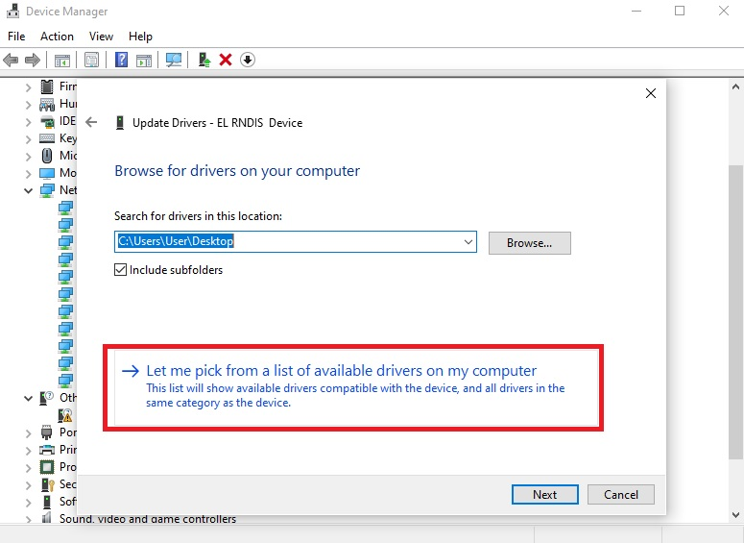

**Step 12**: following below picture, select Next.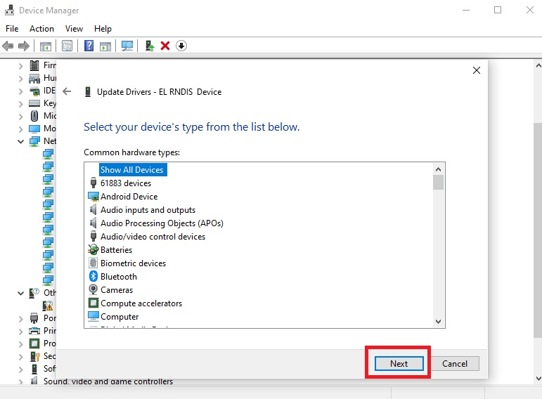

**Step 13**: following below picture, select Have Disk..

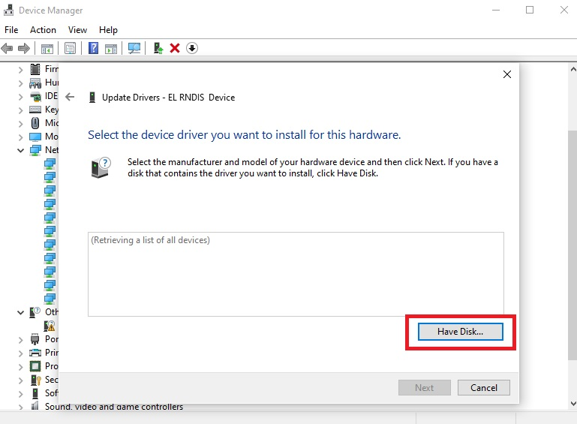

**Step 14:** following below picture, browse the directory where you store the unsigned RNDIS INF file.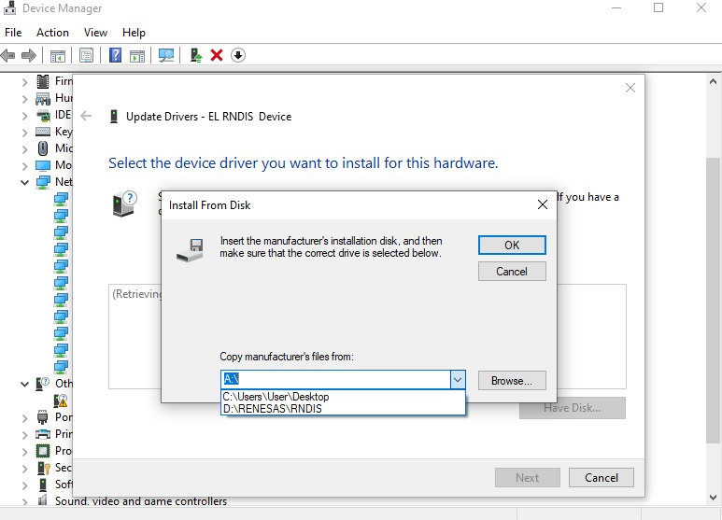

**Step 15**: during the driver installation, you may receive a pop-up message to notify below information. This is due to the use of unsigned INF. Click Install this driver software anyway.

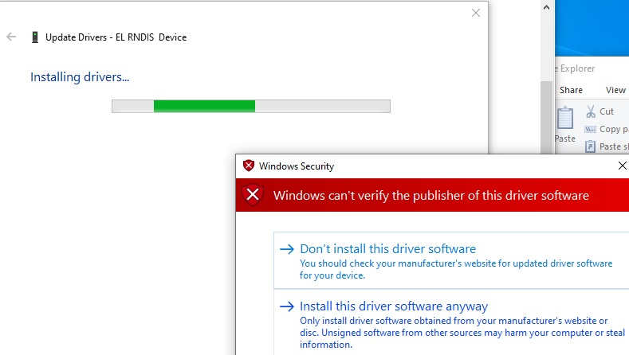

**Step 16**: once the driver installation is completed, you should be able to see message as same as below.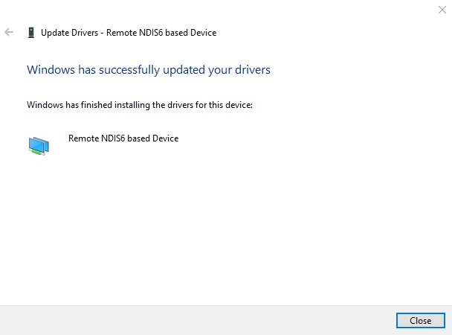

**Step 17**: the RA USB device will be recognized as **Remote NDIS6 based Device**.

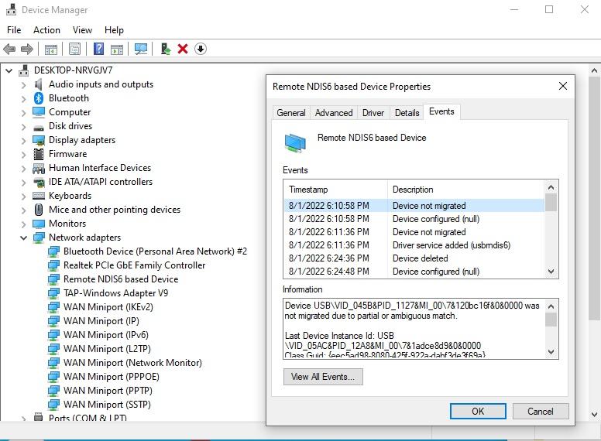

**Step 18**: now, go to Windows Network Connections. There will be an additional Ethernet Adapter which use the connection of Remote NDIS6 based Device.

**Step 19:** For running the RA RNDIS example project, the USB RNDIS network interface use a static IP address which is “192.168.1.3”, so assign a static IP for my PC/NB as well as sub net.

